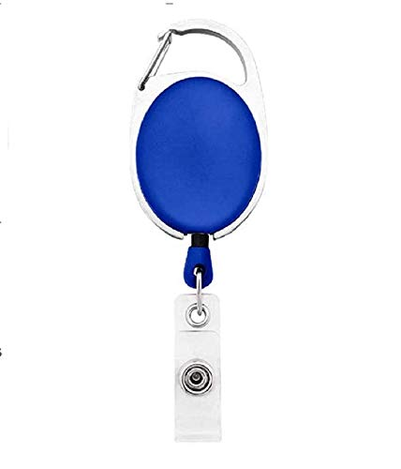



Robert Conner | 
Marketing
02/20/2022
O -ve
12345678

Questions / Queries – Drop an email to mailmukeshkala@gmail.com

